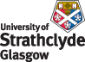
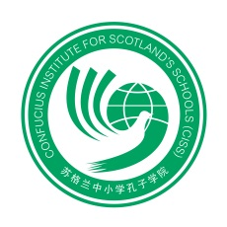
‘Nanjing Little Red Flower Art Troupe’
Booking Form

Evening Performance
Friday, 7 February 2014
Royal Concert Hall
Glasgow
19.30-21.30

Please fill in the application form below and return to Katie Hawkins at CISS, by close of business on Friday 31 January– katie.hawkins@strath.ac.uk

Please complete in BLOCK CAPITALS
School/Confucius Hub:
Accompanying teachers’ names:
Telephone No: | Mobile No:
Email address (for confirmation):
Pupil Names: |  | Year group:
1.
2.
3.
4.
5.
6.
7.
8.
9.
10.
11.
12.
13.
14.
15.
16.
17.
18.
19.
20.
Please state here any special requirements for pupils or teachers:
Please note that schools are responsible for their own risk assessment.

